ROUTES FOR LEARNING
ASSESSMENT BOOKLET

Assessment materials for learners
with profound learning difficulties
and additional disabilities.

(This document is editable.)
Introduction

This booklet forms the basis of the Routes for Learning Assessment. The principles behind the assessment and guidance on meeting the needs of learners with PMLD are provided in the Guidance booklet. Staff should read this guidance and wherever possible undertake training before using the assessment materials.

The behaviours in this Assessment booklet are shown on the Routes for Learning DVD included in the pack.

It is important to note that learners with PMLD will follow a range of pathways through the Routemap, although we believe that they will all pass through the major junctions. These are shown in orange on the map and shown as dark green in the Assessment booklet. Staff should work through all steps initially, as trialling has shown that learners may achieve steps from all areas of the Routemap. The left-hand side of the map focuses on communication skills, and the right-hand side on early cognitive development.

This booklet provides guidance on suitable assessment activities to set up, things to look for during the activity, and teaching strategies to move the learner on. The learner will not necessarily move on to the next numerical step. Consideration must be given to the full range of possibilities shown on the Routemap, bearing in mind the priority needs and physical and sensory abilities of the learner.

At the end of this booklet are two examples of the Routemap. These show the pathways taken by two learners in the DVD: Una, who is working on the earlier stages of the Routemap, and Dion, who is working on the later stages. These make clear the strength of the Routemap in recording significant developments which do not occur in any hierarchical or pre-determined order.
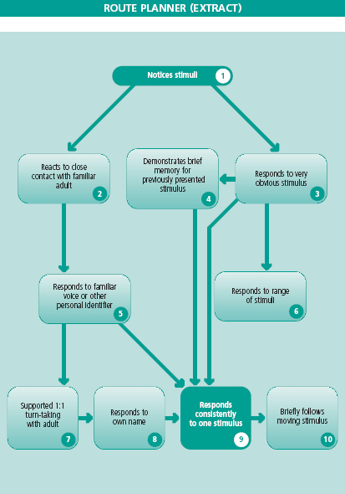
ASSESSMENT ACTIVITIES / THINGS TO TRY
4 Demonstrates brief memory for
previously presented
stimulus

3
Responds to very obvious stimulus

2
Reacts to close
contact with familiar adult

5
Responds to familiar voice or other personal identifier

6
Responds to range of stimuli

1
Notices stimuli

9
Responds
consistently
to one stimulus

10
Briefly follows
moving stimulus

8
Responds to
own name

7 Supported 1:1
turn-taking
with adult

- If there is no obvious response, try videoing the assessment activity.
- Try to find out which are the learner’s strongest senses. Use these first in future activities, but continue to offer other sensory experiences too.
- Start with a very obvious stimulus on or close to the body. Learners may respond to a familiar face or gentle movement.

Note: The Affective Communication Assessment (ACA) (see page 63 of Guidance booklet) may help you to structure your observations.

1 Rock or swing the learner gently, then pause.
Present vibration, e.g. massager or vibrating cushion.
Smear a small amount of a taste on the learner’s lips.
Place the learner’s hand on a fur-covered water bottle.
Play music or a familiar song; musical instruments.
Present a torch reflected on a shiny surface. If there’s no response, try moving it slightly.

2 Hold the learner and talk or sing, leaving pauses for any response.

3 Present an obvious stimulus to the learner in a similar way to 1 above, taking care not to startle. Use the information you have gathered about preferred sense modalities and record outcomes which should be more pronounced than those which occurred in 1 (noticing).
Try new tastes in the form of a lipstick smear.
Try a vibrating cushion, resonance board, or a water bed.
Present different textures, such as warm sand, with which learners can engage. Apply them to different parts of the body.
Try using musical instruments, tapes, musical toys.
Use peep-bo, puppets, pop-up toys.

4 Present the stimulus to the learner. When the learner stops attending, immediately remove and re-present the stimulus (the gap should be less than half a second). Use a stopwatch. If the learner attends for a shorter time to the second presentation, it is likely that the learner has remembered the stimulus. (You may need to try this several times to be sure.)
Note: The stimulus should be neutral (not the face of a familiar adult, not food).
Try using a black and white chequerboard.
THINGS TO LOOK FOR

1+2 Look for any changes in behaviour which are not reflex responses, for example:
- stilling (a momentary pause)
- turning (head, eyes, or body)
- lip/tongue movement
- an eye flicker
- a change in breathing
- tensing or relaxing (you may need to be in close physical contact in
order to perceive this).

3 Look for:
• a change in activity level
• vocalising
• open mouth/tongue movement
• moving fingers, e.g. in sheepskin
• a kick.

4 Look for:
• a decline of interest when the stimulus is repeated
• recovery of interest when a new stimulus is offered.
TEACHING STRATEGIES (TO MOVE PUPIL TO NUMBERED STEP)

- For any stimulus in any modality, try an on/off pattern.
- When no response is observed, make the stimulus more obvious, increasing the contrast between stimulus and background.
- See page 24 of the Guidance booklet for additional information on touch.
- Consult sensory services for advice.

1 Using two staff, one supporting the learner in a sitting position and one at the front, try gently pulling the learner backwards and forwards, and then pausing.
Try different parts of the body (soles of feet, or back of neck may be more sensitive areas).
Try moving the learner’s hand (especially the fingertips) in sheepskin, gel, warm water, etc.
Try sounds of different frequencies, timbre, duration.
In a darkened corner, present a repeated pattern of ‘stimulus: no-stimulus’, i.e. light: no light. (See RNIB software ‘Just Look’.)

2 Choose the learner’s strongest sense to start. Touch/stroke the face or hands.
If the learner responds best to auditory stimuli, try talking and singing close-in to the learner, with pauses for close observation of possible responses.
If the learner responds well to visual stimuli, try getting close-in and exaggerating your facial expression. If there’s no response, try exaggerating your features with face paint or sun block, a luminous wig, glasses, etc.

3 Increase the range, complexity and variety of stimuli used in 1 above. The level of prompting/exaggeration used should be gradually reduced to a more natural level.
If the learner has only shown a response in one sense modality up to this point, then you should seek to extend this to other available senses. Consider your positioning in relation to the learner’s visual field/auditory ability etc. (Refer to Guidance booklet page 22.)
Take care when presenting an ‘unexpected’ stimulus not to cause a startle reaction – good practice would usually be to warn the learner of forthcoming events by touch or voice.
Care must be taken with regard to placement/positioning of visual stimuli. Consider the learner’s visual field, etc. Avoid the learner having to look up as this may cause stiffening and/or backwards movement. (Seek advice from physio).

4 Increase the gaps, looking for evidence of short term memory (see Guidance booklet page 15 – Habituation). Use a variety of stimuli.
Show a new stimulus, rather than the same stimulus again. Look for a recovery of interest.
1
Notices stimuli

4 Demonstrates brief memory for
previously presented stimulus

2
Reacts to close
contact with familiar adult

3
Responds to very obvious stimulus

6
Responds to range of stimuli

5
Responds to familiar voice or other personal identifier

7 Supported 1:1
turn-taking
with adult

8
Responds to
own name

9
Responds
consistently
to one stimulus

10
Briefly follows
moving stimulus

ASSESSMENT ACTIVITIES / THINGS TO TRY

5 Sit close to the learner – hug/touch.
Move towards the learner, speaking or singing.
Draw attention to particular features; for example, exaggeration of a facial expression, the feel of long hair, a perfume smell, etc.

6 Develop activities in box 3 increasing the range, complexity and variety of stimuli.

7 Support the learner in a rocking game, e.g. Row the Boat.
Support the learner to coactively return/push the ball to an adult.
In conversation, take turns – talk and wait for a ‘reply’.
Present/represent a toy or object (visual/musical/vibrating) taking turns.

8 Call the learner by his/her name – try to avoid giving additional cues.

9 Present a familiar visual/auditory/tactile/other sensory stimulus which has been used consistently with the learner. Repeat in the same way several times.

10 Try moving the stimulus vertically as well as horizontally. Try using sound to attract attention, then move to a visual stimulus, e.g. brightly coloured or fluorescent objects.

Note: For 2, 5, and 8, if the learner has VI and an ‘on body’ signal is used, this will usually represent an earlier level of responding.
THINGS TO LOOK FOR

5 Look for:
• stilling/tensing or relaxing
• smiling or a change in facial expression
• turning of the head
• fleeting eye contact
• reaching out/touching.

6 Look for:
• a change in activity level or facial expression
• movement of eyes, lips, tongue
• vocalisation
• tensing/relaxing
• movement of arms/legs/fingers.

7 Look for signs of the learner co-operating or anticipating.

8 Look for responses as in step 6.
Note: Take care that the learner is not responding to other cues such as tone of voice, the staff’s own reaction, a touch, etc. This step requires a response which is different to step 5 above.

9 Look for the learner responding in the same way each time a stimulus is presented.

10 Look for the learner following a stimulus with his/her eyes.
TEACHING STRATEGIES (TO MOVE PUPIL TO NUMBERED STEP)

5 Ensure that all staff who are in regular contact with the learner have a personal identifier or action. This should ideally be an integral part of each person, for example, long hair, a beard, etc.
Encourage voice recognition – use the learner’s name on approach and talk using consistent language.
For learners with VI/HI, a personal, tactile sign may be used.
If the learner is tactile defensive, try other senses.

6 Increase the range, complexity and variety of stimuli used in 1 above.
Gradually reduce prompting and level of stimulation to a more natural level.
If the learner has only shown a response in one sense modality up to this point, then you should seek to extend this to other available senses. Consider your positioning in relation to the learner’s visual field/auditory ability, etc. (Refer to Guidance booklet page 22.) See 3 above for additional information.

7 Use a member of staff to support the learner in taking turns; for example, holding the learner, working hand-over-hand, co-actively, etc. Leave time for the learner to initiate a response.

8 Use the learner’s name consistently in meaningful routines to build association. Cue the learner in with touch or other cues. (Note: Cues should not be used in the assessment process.)
Note that the sense of self can be slower to develop in learners with VI – see page 23 in the Guidance booklet.

9 Check that the learner is comfortable/secure – see page 17 in the Guidance booklet. Use the type of strategies mentioned above.

10 Try using objects with different visual properties, for example, those with different colours or brightness.
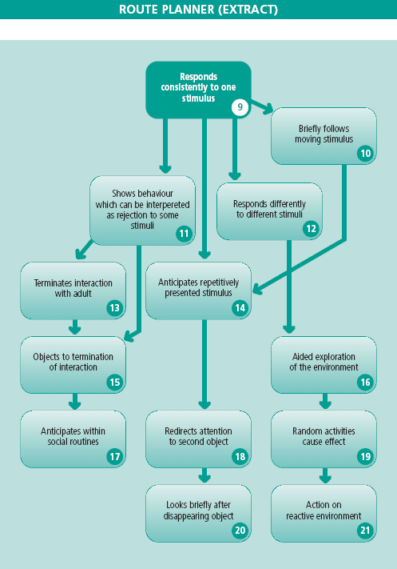
ASSESSMENT ACTIVITIES / THINGS TO TRY
9 Responds
consistently to one stimulus

10
Briefly follows
moving stimulus

12 Responds differently
to different stimuli

11 Shows behaviour which can be interpreted as rejection to some stimuli

14 Anticipates repetitively
presented stimulus

13 Terminates interaction
with adult

16 Aided exploration
of the environment

19 Random activities
cause effect

18 Redirects attention
to second object

15 Objects to termination
of interaction

17 Anticipates within
social routines

20
Looks briefly after
disappearing object

21
Action on
reactive environment

11 Present a range of stimuli (those not preferred by the learner). Watch for signs from the learner such as: turning away, averting the eyes, changing facial expression, movement of arms or legs. To demonstrate this behaviour, the learner must be able to show a positive response to some stimuli.

12 Present stimuli believed to be strongly liked or disliked and note the learner’s reactions.
Do stimuli believed to be liked get different consistent reactions to those believed to be disliked?

13 Watch for this during a range of activities. Extend turn-taking activities and ‘model’ this behaviour.

14 Try:
- placing a vibrating brush, massager, etc., on two different parts of the learner’s body alternately
- presenting a single sound in a regular repetitive pulse pattern
- presenting a visual stimulus alternately in two different positions.

15 Break off interaction during the routine; turn away and stop the activity. Note the learner’s reaction.

16 Place the learner’s hand on an interesting object and assist to feel and pause.
THINGS TO LOOK FOR

11 Look for the learner signalling a desire to stop the activity or interaction; for example, by turning away, pulling a face or pushing.

12 During pauses between stimuli, observe whether the learner appears to be waiting; for example, by tensing up, holding his/her breath, beginning to smile or laugh (for a liked stimulus) – the learner may be anticipating the next repeat.

13 Note how the learner ‘signals’ the end of an interaction, for example, by turning away or averting the eyes.

14 After repeated alternate presentations, look for the learner turning his/her eyes and/or head to the next position before the stimulus appears there.
When sound, vibration or light, etc., is presented in a pulse pattern, look for the learner anticipating the next presentation; for example, the body may stiffen or the eyes widen before the next presentation of a sound.

15 Look for strategies used by the learner to signal that he/she wants the ‘exchange’ to continue; for example, by eye movement, body movement or vocalisation.

16 Look for the learner:
• moving his/her fingers or hand
• smelling or trying to lick/mouth objects
• actively exploring objects in turn.

TEACHING STRATEGIES (TO MOVE PUPIL TO NUMBERED STEP)

11 This ‘rejection’ response is negative and therefore difficult to teach. At first it may be very subtle. At every opportunity reinforce or ‘shape’ the behaviour, responding consistently to confirm the meaning.

12 Try additional strong stimuli in a variety of modalities. Repeat on a number of occasions.
(After consulting the physio):
Place the learner on a thick blanket with the head supported and sweep and swirl the blanket along a slippery floor, building in pauses for a response.
Give the learner a taste/lipstick smear of marmite, lemon juice, rhubarb, chocolate, strawberry.
Present eucalyptus or another strong smell from a smell bank.
Note: Do not repeatedly present stimuli which get a ‘dislike’ reaction on the same occasion; instead, acknowledge the learner’s communication and remove the stimulus.

13 Respond consistently and respect this signal or the learner may try more extreme measures!

14 If there is no response, try sparkly/twinkly items such as fibre-optics, lights or fluorescent rods under UV light. Blow on alternate sides of the learner’s face; blow a raspberry on different parts of body. If the learner has VI and is slow to develop anticipation, return to step 12 and emphasise tactile sense.

15 Ensure staff respond to the signal consistently.

16 Place the learner’s hand or foot in warm water; agitate the water.
Pour sand over the learner’s hand or foot.
Bury the learner’s foot in sand, shaving foam, jelly, or slime.
Use a ball pool, feely bags, etc.
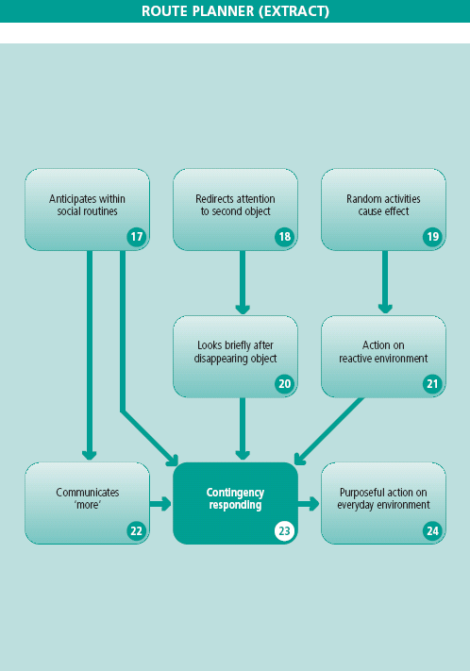
17
Anticipates within
social routines

18
Redirects attention
to second object

19
Random activities
cause effect

20
Looks briefly after
disappearing object

21
Action on
reactive environment

22 Communicates
‘more’

23
Contingency
responding

24
Purposeful action on
everyday environment

ASSESSMENT ACTIVITIES / THINGS TO TRY

17 Within a familiar routine (e.g. ‘drinks’, personal hygiene, social games), pause before the climax.

18 While the learner is attending to an object, offer a second interesting item to encourage redirection of his/her attention.

19 Place the learner on a reactive surface (e.g. a space blanket or resonance board).

20 When the learner is focused on an attractive object, move it slowly and deliberately out of sight and watch for any reaction.

21 Place the learner on an interesting reactive surface and note the response.

22 Engage the learner in an enjoyable activity. Break the activity at a critical point, pause, and await the learner’s response. For example:
• during eating, pause, holding the food in front of mouth
• during singing, pause in an action song
• pause whilst beating on a resonance board.

23 Using an action which you have established that the learner can do (e.g. kicking, pressing a switch), use a reward and observe the rate of response.

24 Try a range of everyday play activities (e.g. sand, water) which require the learner to interact repeatedly to gain an effect.
THINGS TO LOOK FOR

17 Look for signs of anticipation (see 14), as well as smiling or laughing.

18 Look for the learner losing interest in the first object and focusing attention on a new item.

19 Look for:
- independent (but random) movement of hands or fingers
- active exploration by the mouth or other parts of the body
- the learner’s reaction to any ‘effects’ created.

20 Look for the learner looking after the object as it disappears.

21 Look for the learner making attempts to create an action or effect.

22 Look for the learner vocalising/moving/changing facial expression, for example:
- widening the eyes, staring at an object
- moving the arms
- mouth opening, vocalisation
- reaching towards an object, which may be interpreted as a request for more.

23 Look for:
- the learner making something happen independently
- the rate of action increasing when it has an effect; for example, kicking increases when it causes a mobile to move
- whether the learner waits for a reward before pressing a switch again, etc. Refer to Contingency Awareness (26).

24 Look for the learner deliberately making things happen in an everyday environment.
TEACHING STRATEGIES (TO MOVE PUPIL TO NUMBERED STEP)

17 Ensure that consistent routines are used for personal hygiene, drinks, etc. Cue or exaggerate a particular part of the routine to turn it into a game; for example, when changing the learner, develop a game around the need to lift his/her bottom off a bench. This could involve the cue of an exaggerated intake of breath as the learner’s bottom is raised, a dramatic pause in the action, and culminates in repeated bouncing.
Try regular and frequent games such as ‘Ride a Cock Horse to Banbury Cross’, ‘Round and Round the Garden’, or other, personally devised games.

18 Try prompting visual or tactile exploration of a second object, allowing time for the refocus of attention.

19 Use a range of surfaces or toys which react to touch (e.g. a survival blanket, an interactive floor mat, a sound beam. You could also use a ‘little room’ or ‘Be-Active Box’). Provide opportunities for the learner to have an effect ‘by chance’ on the immediate environment, for example, by knocking a noisy toy. Reinforce these actions, prompting a repeat and ensuring a consistent result.

20 Use a variety of situations or places to encourage the learner to ‘look after’ an object which has disappeared from view.

21 Use physical or verbal prompts to initiate exploration, then reduce the frequency of the prompts. Draw the learner’s attention to the effects created.

22 Using stimuli to which the learner has a consistent response, build up a pattern. Pause within the pattern and interpret the learner’s next response as a request for more. For example, while offering food on a spoon, pause just before putting the spoon in the mouth and interpret the learner’s next response (e.g. lips opening) as ‘more’. Extend the distance of the spoon from the mouth. Lips closing could mean ‘no more’.
Pause during bouncing or a resonance board activity with an action song. Interpret body movement or a facial expression as a request for more.

23 At this stage the learner may not fully understand the connection between his/her action and the outcome. Ensure the action obtains a consistent result for the learner to establish the link.
Using a string attached to the learner’s ankle to produce movement of a mobile may be a particularly effective technique: the more the learner kicks, the more the mobile moves. It is important that the learner receives good feedback.

24 Use a range of preferred objects or activities and use prompts to initiate exploration.
Reduce these over time.
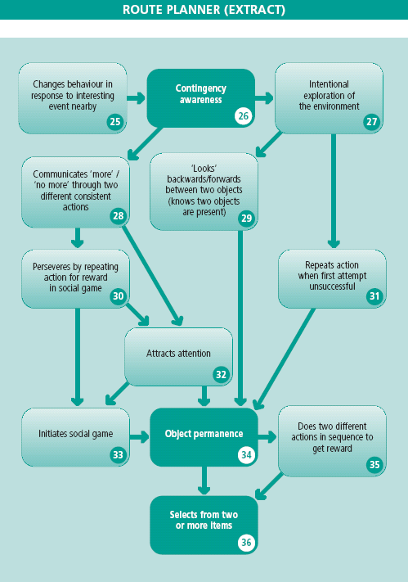
26
Contingency
awareness

27
Intentional
exploration of
the environment

25 Changes behaviour in
response to interesting
event nearby

28 Communicates ‘more’ / ‘no more’ through two different consistent actions

29 ‘Looks’
backwards/forwards
between two objects (knows two objects are present)

30 Perseveres by repeating
action for reward
in social game

32
Attracts
attention

33
Initiates social game

34
Object permanence

35 Does two different
action as in sequence to
get reward

36
Selects from two
or more items

31 Repeats action when first attempt
unsuccessful

ASSESSMENT ACTIVITIES / THINGS TO TRY

25 Introduce a second toy/stimulus/adult/peer nearby while the learner is engaged in an activity.

26 Provide a switch for a toy or provide a wobbly toy, wind chimes, etc., which can be operated by an action that the learner has already acquired.

27 Observe reactions to a less familiar environment, when accompanied by a familiar adult.

28 Observe the learner’s reactions to a less preferred activity or food, etc. Note the actions which may indicate ‘no more’. This should be distinct from the action used to indicate ‘more’.

29 Place two attractive objects on the learner’s tray to be explored visually or by touch; bring both to the learner’s attention and wait.

30 Try pausing in an established routine; as the learner requests ‘more’ (as in 22), continue to delay the response.

31 Try:
- moving the learner’s switch slightly
- changing the surface to make the toy harder to move
- using an adjustable pressure switch, increasing the pressure of the switch slightly.

32 Stay within the learners sight/hearing but do not interact; wait to see if the learner shouts, waves or cries, etc. This might be a minimal response.

33 Building on 30, approach the learner and wait for him/her to initiate a game.

34 Engage the learner’s attention to a shiny, noisy or furry object. Either move the item out of sight, keep it quiet or move it just out of reach. Does the learner ‘search’?

35 Build on an established routine to use two responses to gain a reward; for
example, the learner pressing a first and then a second switch in sequence in order to get a reward on a computer programme.

36 Present two items to which the learner will respond; for example, brightly coloured or noisy toys, a smell, a taste of drink, etc. Observe the learner to ascertain if the response to one item has a longer duration, or whether there is an obvious change in activity level.

THINGS TO LOOK FOR

25 Look for the learner ‘noticing’ a second event/stimulus and reacting or changing behaviour; for example, by turning, attending or vocalising.

26 Look for the learner acting with intent – and more consistently; for example:
- waiting for a reward to end before trying again, linking a particular action
with its consequence
- a change in facial expression or concentration
- increasing accuracy.

27 Look for any form of exploration; for example, the learner looking around, reaching out, or a body movement if on the floor.

28 Look for a response which may indicate ‘no more’; for example, eyes closing, turning away, closing of the mouth. Reinforce and build upon this, responding consistently on every occasion.

29 Look for the learner attending to, or feeling each of two objects in turn and redirecting his/her attention.

30 Look for the learner repeating a request for more, despite a delay.

31 Look for an example, such as:
- the learner missing a switch the first time, or failing to depress it sufficiently, but trying again and succeeding.

32 Look for the learner trying to attract attention of familiar staff nearby.

33 Look for the learner attempting to initiate a game through a signal used in 30 or by other means.

34 Look for:
• the eyes looking towards the point of disappearance for a brief time
• stilling, head turning, a facial expression when a noise stops
• searching briefly by feeling a tray for an item removed from grasp
• increased duration of searching.
If the learner has a significant visual impairment, object permanence may not appear until further down the Routemap. (See Guidance booklet page 56 for information on object permanence.)

35 Look for a decrease in time between the two actions. These should be done in sequence rather than pausing after the first action.

36 Look for:
- increased eye contact with one item
- a greater change in facial expression in response to one noise when two are presented in an alternating pattern. Leave enough time for any responses
- an increased level of activity (e.g. arm or leg movements) during a pause following a taste of one particular food.
TEACHING STRATEGIES (TO MOVE PUPIL TO NUMBERED STEP)

25 Introduce a second activity – draw the learner’s attention to it (e.g. an adult or peer entering the room).

26 Encourage the same action to obtain a variety of effects. Ensure that every repeat of the action is successful.

27 Provide interesting visual/tactile experiences in a controlled way by regularly introducing new stimuli and drawing attention to them.

28 Note even a slight response or change in expression to an activity which the learner wishes to end. Reinforce and shape this behaviour by saying or co-actively signing ‘finished/no more’ and clearly finishing the activity.

29 Try prompting exploration of each object in turn, allowing time to refocus attention. Both objects need to be in the learner’s visual/spatial field.

30 Use an established routine of a social game, pause, and then wait for the action to be repeated. Lengthen the delay, encouraging the learner to persevere.

31 You may wish to encourage problem solving by moving the position of the switch slightly. However, beware of confusing or frustrating the learner.
This step can be taught in a range of situations (i.e. not IT based).

32 Set up situations where familiar staff are nearby, but not interacting. Consistently reinforce attempts by the learner to gain their attention.

33 See 30. Prompt the learner to initiate a game and respond to this; for example, the learner knocks a toy off the table and then attracts attention to get it back.

34 If there is no response to the object being removed from the field of attention:
• try partially covering the object, or use a see-through cloth
• use a moving object under the cloth
Ensure that the learner’s attention is focused on the place from where the object disappeared (e.g. make a noise with it from just outside the learner’s field of vision); then bring the object back into sight for a short time from this direction.
Prompt the learner’s hand to reach for the object in the direction in which it was moved away.

35 The actions used here should be established responses. Support the learner to build a new routine by giving a reward only after the second action has been completed. Reduce the strength and frequency of prompts.

36 Offer two items in a variety of situations.
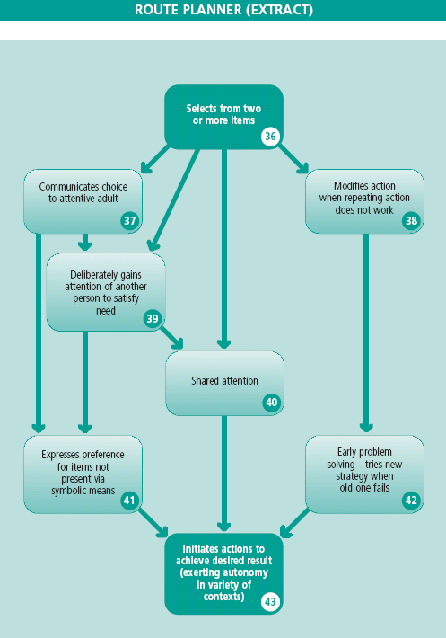
36
Selects from two
or more items

37
Communicates choice to attentive adult

38
Modifies action
when repeating action
does not work

39 Deliberately gains
attention of another
person to satisfy
need

41 Expresses preference
for items not
present via
symbolic means

40
Shared
attention

43 Initiates actions to achieve desired result (exerting autonomy in variety of contexts)
42
Early problem
solving – tries new
strategy when
old one fails

ASSESSMENT ACTIVITIES / THINGS TO TRY

37 Offer two items simultaneously. Observe the learner closely for obvious or increased attention to one of the items which communicates his/her preference.

38 Within a routine based on established behaviours (see 33), ensure a reward is not given.
Note the learner’s reactions.

39 Avoid attending to the learner. Observe the strategy which is used to gain attention, with no prior intervention. These may include:
- vocalising until an adult appears, then stopping
- pushing items off a tray and then smiling when an adult appears
- stopping activities to press a switch which has consistently been used (with support) to call an adult.

40 Point to an item in the distance. Does the learner looks towards the item then back at the adult?
Move to music. Does the learner join in with similar movement?
Stroke a dog. Does the learner also touch the dog and smile at the adult?
The learner should join the adult in attending to a stimulus, confirming the attention of the adult visually throughout.

41 Present to the learner objects of reference/pictures/symbols for items of interest which are not present. Does the learner indicate or pay attention to one of the symbols in order to request a preferred item?

42 Use an established routine where the learner’s action results in a particular reward, as in 36. Delay the reward to see if the learner then uses a different action in order to get the reward.
For example:
- where knocking a toy causes it to make a noise, alter the routine so that the toy makes a noise after a knock and a vocalisation. Repetition of the first action does not get a reward
- use a computer program that is operated by the alternate pressing of two switches.

43 Stand or sit in view of the learner, but do not pay attention to him/her. Does the learner then try to gain your attention? Does he/she then go on to request an item which is out of sight or reach?
THINGS TO LOOK FOR

37 Look for:
• smiling
• eye pointing
• reaching
• turning towards a preferred item.

38 Look for the learner repeating an action then trying a new or modified action in an attempt to get a response.

39 Look for all unprompted attempts to gain adult attention; in particular at times when an adult is not expecting them. Strategies can be taught (e.g. pressing a particular switch which could be present on a tray or chair), but they must come to be used on the learner’s terms not just after adult encouragement.

40 Look for the learner gaining attention of an adult, for example:
- looking towards or indicating a stimulus and then looking back to the adult
- stilling to a sound, or moving to music, and then looking back to the adult
- touching an item and then feeling for the adult’s hand.
Look for the learner showing pleasure in sharing, or trying to ‘comment’ on the item.

41 Look for the learner giving attention to a symbol for a preferred item and then waiting for the item to be presented.

42 Look for a reduction in the time during which the learner tries the original action in order to gain a reward. When failure of the original strategy is recognised, and as soon as an attempt at a new action is made, a reward should be given. As the learner becomes aware that the increased original action will not work, a new strategy will be attempted more quickly.

43 Look for:
- attempts to gain adult attention (as above) and make a request; for example, vocalising for attention and then touching a symbol on a tray.
- the learner timing switch-presses to get a desired result in a computer programme.

TEACHING STRATEGIES (TO MOVE PUPIL TO NUMBERED STEP)

37 Offer a preferred item alongside a non-preferred item. If there is no clear response to the preferred item, either move it, bring it closer, or make it make a noise to attract the learner’s sustained attention. Try this with a variety of objects and situations.

38 Prompt/scaffold a new (but similar) action and ensure that the learner gains the response.
Try a different switch or toy that requires a similar input from the learner; for example; use a mobile attached to a wrist, but slackened so that the learner needs to make larger movements to get the mobile to work.

39 Choose an action in the learner’s repertoire to which an adult can respond consistently by giving attention. For example:
• pressing a switch (left available in same position)
• vocalising above a certain sound level
• moving arms/legs/eyes, etc.
By responding consistently to the action, the learner is encouraged to carry out the action on future occasions in order to gain adult attention as a reward.

40 Teach shared attention by prompting the learner (verbally or with touch) to look at, listen to, or feel an item of adult choice, then to attend to the adult and the item in turn.
Take the opportunity to share a stimulus to which the learner is attending. Encourage attention to the stimulus and then the adult in turn. This is key for all future communication.

41 Show a photo or symbol of a preferred item to the learner before presenting a stimulus. Repeat this to build up the association. Now show two objects/photos/symbols – one for the preferred item plus one other – then present the item related to the symbol which has been indicated.

42 Encourage/shape a second, different action when the learner repeatedly tries the first. Try:
- prompting the learner to use another action which is in his/her repertoire – then giving the reward
- using computer programmes which require alternate pressing of two switches – reward on the second switch
- using single switch programmes where the timing of switch-pressing is important
- moving the switch so that the learner needs to use the other hand.

43 Increase the variety of situations where demands are put on the learner to gain attention and make requests. Ensure that responses from adults are quick and consistent. Do not anticipate the learner’s wants – create opportunities for communication.

Acknowledgements

We are grateful to the Working Group who developed these materials:

Dr Jean Ware, Project Consultant, St Patrick’s College, Dublin
Wendy Jones, Ysgol Heulfan, Wrexham
Phil Martin, Ysgol Crug Glas, Swansea
Lynn Alton, Ysgol Y Bryn, Flintshire
Pauline Loftus, Ysgol Pendalar, Gwynedd

We would also like to thank the schools and teachers that provided materials for the DVD:

Trinity Fields School, Caerphilly
Crownbridge School, Torfaen
Ysgol Hen Felin, Rhondda Cynon Taf
Stewarts School, Dublin
St Mary’s Hospital and Residential School, Dublin

and the schools who trialled the materials and gave us valuable feedback:

Briton Ferry School, Neath Port Talbot
Ty Gwyn School, Cardiff
Ysgol Llwyn yr Eos, Ceredigion
Ysgol Penllergaer, Swansea
Ysgol Bro Tryweryn, Gwynedd
Portfield School, Pembrokeshire
Ysgol Pen y Cwm, Blaenau Gwent

© Crown copyright 2006

Ref: AC/GM/0612

First published April 2006

Reproduction, storage, adaptation or translation, in any form or by any means, of this publication (not including the logo) is permitted free of charge. It must be re-used accurately and not in a misleading context. The material must be acknowledged as Crown copyright and the title of the source publication should be given. Where any third party copyright material has been identified permission must be sought from the copyright holders concerned.

Produced by the Qualifications and Curriculum Group, Department for Education, Lifelong Learning and Skills, Castle Buildings, Womanby Street, Cardiff CF10 1SX.

